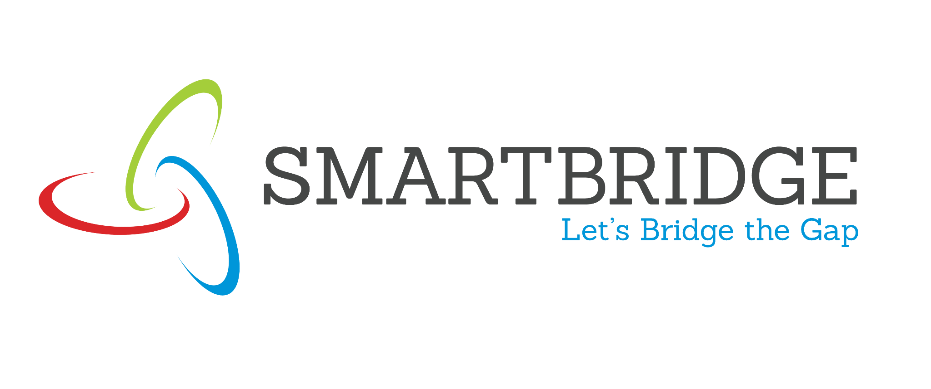 |  | 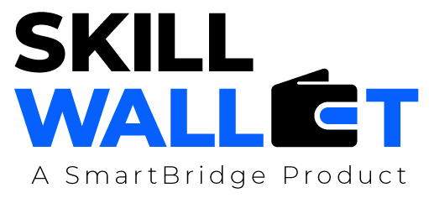

Date | 15 March 2026 27 June 2026
Team ID | xxxxxx EduGenie - Google Gemini Powered Learning Assistant
Project Name | xxxxxx EduGenie - Google Gemini Powered Learning Assistant
Maximum Marks | 5 Marks
Problem-Solution Fit Canvas:
Use the framework below to ensure your proposed solution accurately addresses the root causes, behaviors, and limitations of your target audience. Fill out the canvas in the respective boxes just like the original visual template.
1. CUSTOMER  High school and college students learning SEGMENT(S) [CS] independently; self-directed online learners. | 6.  Limited study time; lack of access to private tutors; depends on internet connectivity. CUSTOMER  LIMITATIONS  EG. BUDGET, DEVICES [CL] | 5.  Search engines (too generic), online courses (static), AVAILABLE AI chatbots (no structure).  SOLUTIONS  PROS & CONS [AS]
2. PROBLEMS / PAINS + ITS FREQUENCY [PR] roadmaps. | 9. PROBLEM ROOT /  Traditional material lacks personalization and active testing. CAUSE [RC] | 7. BEHAVIOR  Stitches generic tools together; high drop-out rate. + ITS INTENSITY [BE]
3. TRIGGERS TO ACT Upcoming exams; assignments; starting a new [TR] programming language. | 10. YOUR SOLUTION EduGenie: Multi-module FastAPI app with adaptive explain, quiz, roadmap, and local fallback. [SL] | 8. CHANNELS OF Browser-based glassmorphic dashboard. BEHAVIOR [CH]  ONLINE
4. EMOTIONS  BEFORE / AFTER [EM] Confident, relieved, clear path. |  | OFFLINE

